Title English Name Title English Name



xxx¹ , xxxxx² , xxxxxx³

^{1,2}Department of xxxx, College of xxxxx, University of xxxxx-Iraq
³Department of xxxx, College of xxxxx, University of xxxxx-Iraq
Corresponding Author E-mail:xxxxxxx¹
Phone Number /

Research Details

Research Title:

Proposed Journal:

Researchers’ Information
 | Principal Investigator | Co-Author 1 | Co-Author 2
Name (English)
Name (Arabic)
Academic Title
Email
ORCID
Affiliation
Presenter

ABSTRACT
One of the most significant helminthozoonosis in Iraq and around the world is cystic echinococcosis, which occur by the etiologic agent of Echinococcus granulosus and it’s distinguished by considerable intra-specific variability (genotypes G1–G10). DNA was extracted from 48 isolated cysts (25 sheep, 12 goats and 11 human) and used as templates to amplify using Trachsel method to differentiate Taeniide (Echinococcus spp. and/ or Taenia spp.) and mitochondrial cytochrome c oxidase subunit one (COX1) gene for genotyping. The PCR products were sequenced, and sequence analysis was used to further evaluate the data. Out of 48 separated of the host cysts, 36 isolates displayed the G1 genotype (100%), and in 12 samples, a nucleotide substitution at position 58 (T→C) results in polymorphism (99.9%). The G1 is considered that the most contagious and prevalent genotype of E. granulosus in the world. Our investigation revealed that, a single genotype that may be in charge of the disease's infectivity in sheep, goats, and human as well as its persistence in endemic areas. these epidemiological findings could be guided the successful hydatidosis control measures in Erbil Provence
Keyword /

Title Arabic Name Title Arabic Name

Xx Author Arabic name ¹،xxx²،xxxxx³
¹ قسم xxx، كلية xxxxx، جامعةxxxxxx -العراق
² قسم xxx، كلية xxxxx، جامعةxxxxxx -العراق
Corresponding Author E-mail:xxxxxx¹

الملخص
أحد أهم أمراض الديدان الطفيلية في العراق وحول العالم هو داء المشوكات الكيسي، والذي يحدث بواسطة العامل المسبب لمرض المشوكة الحبيبية ويتميز بتباين كبير داخل النوع (الأنماط الجينية G1 – G10). تم استخراج الحمض النووي من 48 كيسًا معزولًا (25 خروفًا و12 ماعزًا و11 إنسانًا) واستخدم كقوالب للتضخيم باستخدام طريقة Trachsel للتمييز بين Taeniide (Echinococcus spp. و/أو Taenia spp.) والوحدة الفرعية الأولى من السيتوكروم c أوكسيديز الميتوكوندريا (COX1). الجين للتنميط الجيني. تم تحليل تسلسل ناتج تفاعل البلملرة المتسلسل، وتم استخدام تحليل التسلسل لمواصلة تقييم البيانات. من بين 48 عزلة من الكيسات المضيفة المنفصلة، ​​اظهلرت 36 عزلة النمط الجيني G1 (100٪)، وفي 12 عينة، أدى استبدال النوكليوتيدات في الموضع 58 (T → C) إلى تعدد الأشكال (99.9٪). يعتبر G1 النمط الجيني الأكثر وجودا" وانتشارًا نوع E. granulosus في العالم. كشفت دراستنا أن نمطاً جينياً واحداً قد يكون مسؤولاً عن عدوى المرض في الأغنام والماعز والإنسان وكذلك استمراره في المناطق الموبوءة. يمكن أن تكون هذه النتائج الوبائية بمثابة دليل على التدابير الناجحة لمكافحة الداء المائي في محافظة أربيل.
الكلمات المفتاحية /

- Introduction

Carnivorous mammals, mostly dogs but occasionally cats, are infected by the tapeworm Echinococcus spp., which serves as the intermediate host. Cystic mass lesions are most usually caused by the extraintestinal larval stages of Echinococcus species in the liver, although they can also affect almost all other organs. Humans serve as an accidental and typically "dead-end" intermediate host for echinococcal infections, unless they are eventually consumed by a canine predator to complete the life cycle [1]. As a result of decreasing animal productivity, this disease poses a severe threat to remnants health in numerous rural places worldwide [2], and the infection is obtained through oral uptake of eggs from the final host's feces. The oncosphere larvae emerge from the eggs, breach the intestinal wall, and were circulated in many organs where they settle and growth into the metacestode stage. Eventually, the metacestode produces a significant amount of protoscolices [3]. Understanding the patterns of worm transmission in various geographic areas by CE genotyping is crucial for developing effective control measures and assessing the differences in pathogenicity [4,5]. According to genetic classification, which is mostly based on the homology of the sequences of the two mitochondrial genes cytochrome C oxidase subunit 1 (COX1) and reduced nicotinamide adenine dinucleotide subunit 1 (NAD1), ten different strains have previously been genetically characterized [6]. Five different species have been identified as existing within the E. granulosus species complex by modern taxonomic classification. The genotypes of these include E. granulosus s.s. (G1-G3), E. equinus (G4), E. ortleppi (G5), E. canadensis (G6-G10), and E. felidis [7, 8]. The G1 genotype, often known as the "sheep strain," can infect humans, goats, cattle, camels, and pigs in addition to causing viable cysts in sheep [9]. In order to evaluate the genetic diversity of Echinococcus granulosus sensu stricto (s.s.) metacestodes from four European countries, the DNA sequence analysis of the COX1 gene was used [10]. The objective of the current study was to identify the species of Echinococcus present in the intermediate hosts in Erbil Provence by using multiplex PCR to allow the comparative analysis of three nucleotides and also to sequence the PCR-amplified mitochondrial COX1 gene of hydatid cysts isolated from sheep, goats, and humans in order to establish their genotype.
- Materials and methods
Animals and human cystic echinococcus (CE) were collected during the period from July 2022 to June 2023.
2.1- Samples Collection:
The entrails of all slaughtered sheep and goats were examined precisely examined for the existence of CE, when a cyst had been seen; all information about the slaughtered livestock and infected organs were recorded on Questionnaire form. A total of 37 animals (25 sheep and 12 goats), including 10 pulmonary and 27 hepatic cystic echinococcus were studied. Furthermore, patients with CE who were admitted to two teaching hospitals (Rizgary Teaching Hospital and Komary Teaching Hospital) provided cyst samples in Erbil Province. The geographic origin and cyst location of patients were noted. Human CE were obtained from 11 patients undergoing surgical operation aging 13–69years, they included: 8 hepatic and 3 pulmonary CEs. The germinal layer of the cysts from human were taken after surgical operation and kept in 70% ethanol and stored at refrigerator (2-8ºC) until used.
2.2- Molecular assay
Twenty five mg of germinal layers from animals and human cysts were used for DNA extraction, using the procedure of [10, 11]; from which 80-100μl was obtained, using Bio- Tech Korea, observing the guidelines provided by the manufacturer instructions. PCR product was amplified using Go Taq (Promega, Madison, WI, USA). To define the species of CE; Multiplex PCR method was used with Primer sequence of: Cest₁ E. multiocularis (5’-TGCTGATTTGTTAAAGTTAGTGATC-3’), Cest₂ E. multiocularis (5’- CATAAATCAATGGAAACAACAACAAG-3’), Cest₃ Taenia spp. (5’-YGAYTCTTTTTAGGGGAAGGTGTG-3’), Cest₄ E. granulosus (5’-GTTTTTGTGTGTTACATTAATAAGGGTG-3’) and Cest₅ Taenia spp. (5’-GCGGTGTGTACMTGAGCTAAAC-3’) to amplify 123bp for the E. granulosus, 275bp for the Taenia spp. and 400bp for E. mutlilocularis. The amplification reaction mixture (30μl) consisted of 13.6μl of (2X) Go-Tag master mix, 14.4μl of primer mix (12 pmole) (1.2 μl of primers Cest₁, Cest₂, Cest₃, Cest₄ and 9.6 μl of primer Cest₅) and 2 μl of template DNA. The amplification reaction was performed using AB Applied BioSystem thermo-cycler (Veriti 96 Well Thermal Cycler- Singapore), under the following conditions: a pre-amplification step at 94ºC for 5minutes, followed by 40 cycles with denaturing at 94ºC for 30s, annealing at 58ºC for 90s and extension at 72ºC for 10s, and for the final elongation of DNA strands, an ending-extension at 72ºC for 5 min. Water instead of DNA was included in each set of PCR reactions as the negative control. For genotyping of extracted DNA fragment, Cox1 gene was amplified by PCR using a genus-specific primer set (5'- TTTTTTGGCCATCCTGAGGTTTAT-3' and 5'-TAACGACATAACATAATG AAAATG -3'). The PCR mixture was prepared in a 50μl volume containing 2μl template DNA, 25μl of (2X) Go-Tag master mix, 25 pmol (2.5 μl) of each primers (foreword and reverse). The amplification was performed by adding 1 cycle at 94◦C for 5minutes before the 35 cycles of the PCR (Hot Start PCR) and adding 1 cycle at 72◦C for 5min after the 35 cycles. The PCR parameters were as follows: 35 cycles of initial denaturation for 30s at 95◦C, annealing for 30s at 55◦C and elongation for 30s at 72◦C). The PCR products was performed in 1.5% agarose and visualized by UV tans-illumination (Bio-Rad Gel Doc.). The same PCR product was submitted commercially (Macrogen Inc. South Korea) to sequencing by using the same primers cox1 gene in both directions and The BLAST method (http://www.ncbi.nlm.nil.gov/BLAST/) was used to compare the nucleotide sequence to the NCBI database.
2.3- Nucleotide Sequence and Phylogenetic Tree Analysis
The species of Echinococcus was confirmed by analyzing the nucleotide sequences of the cox1 gene. The sequences were aligned through the ClustalW algorithm within UGENE [12], provided by BioEdit v7.2.5 [13], with sequences available in the GenBank (NCBI) database. Phylogenetic analyses were performed on individual partial gene sequences using MEGA software (Molecular Evolutionary Genetics Analysis 3.1; (http://www.megasoftware) and the neighbor-joining were used to build the tree.
- Results and Discussion

The multiplex PCR amplification for species specific was successfully performed on the 48 CE isolated from different intermediate hosts and the acquired data revealed that all single and multiple cysts (germinal layers) isolated from all intermediate host were E. granulosus which was 123bp as expressed in figure 1. Regarding the genotyping of extracted DNA using cox1 gene; all positive samples confirmed as Echinococcus granulosus yielding 444pb, corresponding to the mitochondrial cox-I gene as shown in figure (2).The DNA sequences generated of 36 (75%) samples were 100% identically to the sequences of E. granulosus s.s. (G1) under the accession number (LC476648 and MT318687) in Genbank and 12 (25%) with E. granulosus (G1BC) due to nucleotide changes (T→C) at position 58 as shown in figure 3. The ClustalW application within UGENE was also used to perform the multiple alignments of the nucleotide sequences as indicated in figure 4, it was discovered after drawing the phylogenic tree that all of the samples of hydatid cyst belonged to the G1 and G1BC strain.

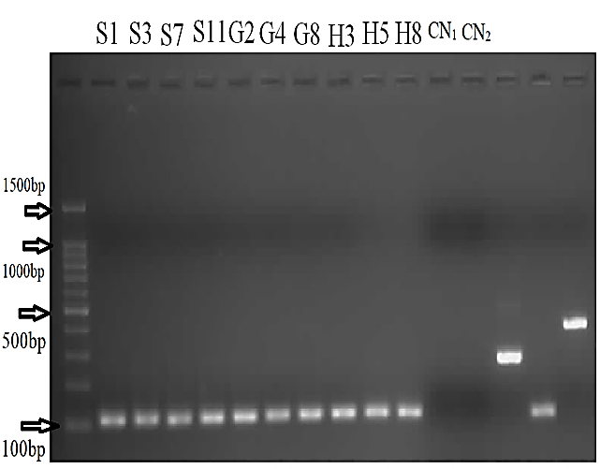
Fig. 1: Multiplex PCR of Echinococcus spp. and Taenia spp isolates of intermediate host from Erbil Provence. In the multiplex PCR only the 123 bp fragment amplified, indicating that the intermediate host could be infected with E. granulosus. DNA marker size (100- bp DNA ladder), Cn₁=Control DNA extraction, Cn₂=Control negative PCR, lanes S1, S3, S7, S11, G2, G4, G8, H3, H5 and H8–specific product for E. granulosus isolated from intermediate hosts. Notes: S= Sheep, G= Goats, and H= Human)

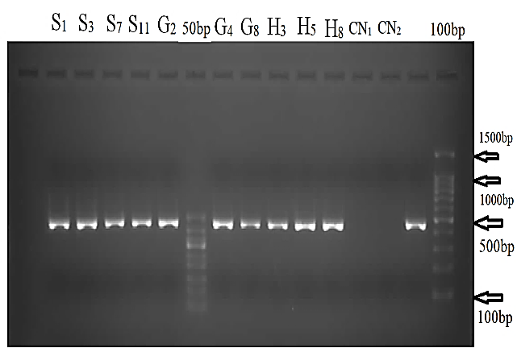
Fig. 2: Gel documentation of PCR results of E. granulosus template DNA using mitochondrial cytochrome C oxidase subunit 1 gene.

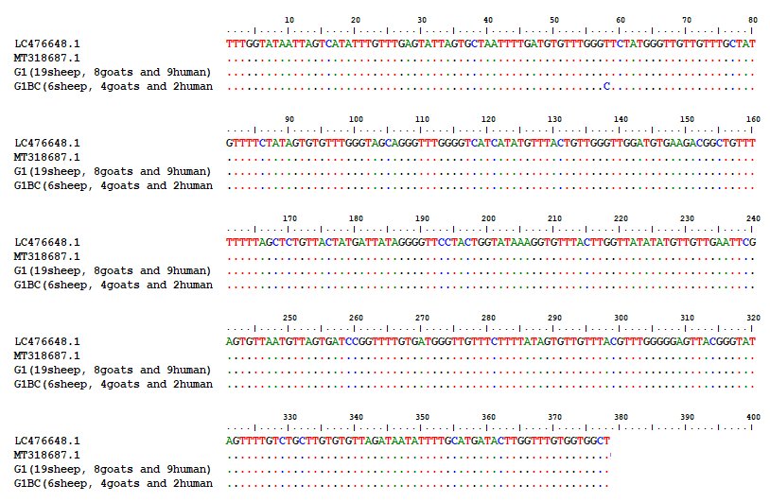
Fig. 3: Genotyping of E. granulosus in various hosts identified by mitochondrial analysis in Erbil Province

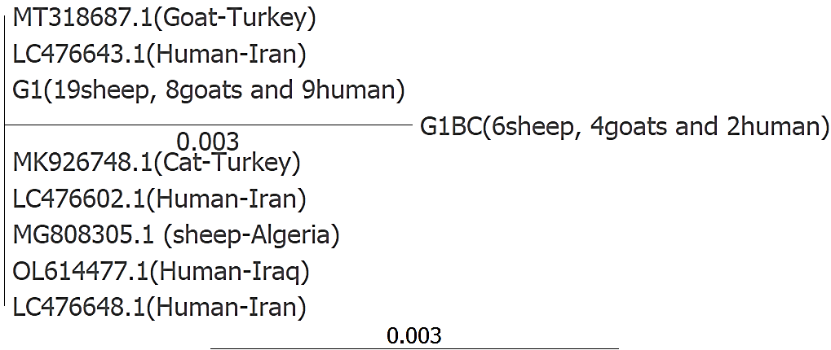
Fig. 4: Maximum likelihood bootstrap tree revealed the relationships of the haplotypes of cox1 gene fragment for E. granulosus isolates with those submitted in Genbank

Multiplex PCR, a very sensitive technique, was developed by [14] and it was employed to separate E. granulosus complex, E. multilocularis, and others Taeniidae from fecal samples, but in the present study, it has been used with some modifications for the identification of germinal layer of CE and it was successful for this genus. Because multiplex PCR method is unequivocal for the distinguish of taeniidae (Echinococcus spp. and Taenia spp.) from intermediate host [15], and furthermore, the primers used to identify E. granulosus complex and Taenia species are not completely specific for the species that they are meant to detect. Additionally, primers can find certain non-taeniid cestodes and the E. granulosus primers also amplify DNA from the recently identified E. shiquicus, E. vogeli, and E. oligarthrus [16].
Several molecular methods have been used to distinguish the numerous Echinococcus strains/species [17] . The mitochondrial cox1 gene was used in this study because it is one of the markers used to distinguish different strains, and cox1 was helpful in identifying Echinococcus variations [18]. The phylogenetic analysis of concatenated sequences showed that the amplified DNA had 100⁒ identity with the COX1 gene of E granulosus (G1-genotype). The results of this investigation were agreed with the results of other investigator like [19] in Iran and [20] in Turkey, reported that the majority of the samples (19 sheep, 8 goats and 9 human) were 100% identity with human strain G1 (GenBank LC476648 and MT318687) and 6 sheep, 4 goats and 2 human samples was 99.9% identity with LC476648 and MT318687 due to slight variation was observed in position 58 (T→C). After that, when they were aligned with current Iranian and Turkish G1 sequences, they had higher percent identities of 99.9–100%. Results of the present works represented that, most of the isolates analyzed belonged to the G1 genotyping (sheep strain), and shown that this strain is actively transmitted throughout the Kurdistan region and surrounding countries [21-23], and the sheep play a significant role in human transmission cycle and the and the absence of G4, G6, and G7 genotype in this investigation is probably explained by the fact that in Kurdistan region, these genotype are specific to the species that were not slaughtered in slaughter house, like baffle, horse and pigs. The result disagreement with [24], who observed that in Iraq, the majority of CE patients (60) were infected with hydatid cysts of either G4 (43⁒), G5 (20⁒), and G6/G7 (7⁒) and [25] reported that, 38 isolates were sequenced by using polymerase chain reaction to amplify mitochondrial COX1 gene in the south-east of Iran and The genotype G1 was most prevalent in sheep (86.7%), cattle (80%), camels (44.4%), and goats (100%). Furthermore, [26] revealed that, of the 20 goat samples tested, 17 isolates (85%) were of the sheep strain's G1 genotype and the other three isolates (15%) were of the G6 genotype.
- Conclusion
The multiplex PCR assay is benefit for differential diagnosis, molecular characterization and epidemiological survey of Echinococcus spp. and Taenia spp. The current study's genotyping data strongly show that the majority of the animal and human isolates found in Erbil Provence are of the G1 and G1BC genotype. In order to properly condemn their impacted offal and conduct further genetic investigation, we propose developing new methodologies. These safety measures will be very helpful in shortening the life cycle of the Echinococcus spp. and managing the illness.
- Conflict of interests: The authors declared no conflicting interests.
- Sources of funding: This research did not receive any specific grant from funding agencies in the public, commercial, or not-for-profit sectors.
- Author contribution: Authors contributed equally in the study.

References

[1] Avila HG, Maglioco A, Gertiser ML, Ferreyra MP, Ferrari F, Klinger E, et al. First report of cystic echinococcosis caused by Echinococcus granulosus sensu stricto/G1 in Felis catus from the Patagonian region of Argentina. Parasitology Research. 2021;120:747-50.
[2] Hajimohammadi B, Dalimi A, Eslami G, Ahmadian S, Zandi S, Baghbani A, et al. Occurrence and genetic characterization of Echinococcus granulosus sensu lato from domestic animals in Central Iran. BMC Veterinary Research. 2022;18(1):1-13.
[3] Mehmood N, Muqaddas H, Ullah MI, Saarma U, Varcasia A. Genetic structure and phylogeography of Echinococcus granulosus sensu stricto genotypes G1 and G3 in Pakistan and other regions of the world based on nad5 gene. Infection, Genetics and Evolution. 2022;98:105223.
[4] Hua RQ, Du XD, He X, Gu XB, Xie Y, He R, et al. Genetic diversity of Echinococcus granulosus sensu lato in China: Epidemiological studies and systematic review. Transboundary and Emerging Diseases. 2022;69(5):e1382-e92.
[5] Sadjjadi SF, Mohammadzadeh T, Hafezi F, Sadjjadi SM. Evaluation of the Ability of Antigen B Originated from Echinococcus granulosus Sensu Stricto and E. canadensis for the Diagnosis of Confirmed Human Cystic Echinococcosis Using ELISA. Iranian Journal of Parasitology. 2022;17(3):358.
[6] Manterola C, Totomoch-Serra A, Rojas C, Riffo-Campos ÁL, García-Méndez N. Echinococcus granulosus sensu lato genotypes in different hosts worldwide: a systematic review. Acta parasitologica. 2021:1-25.
[7] Hüttner M, Siefert L, Mackenstedt U, Romig T. A survey of Echinococcus species in wild carnivores and livestock in East Africa. International journal for parasitology. 2009;39(11):1269-76.
[8] Nakao M, Lavikainen A, Yanagida T, Ito A. Phylogenetic systematics of the genus Echinococcus (Cestoda: Taeniidae). International Journal for Parasitology. 2013;43(12-13):1017-29.
[9] Fadakar B, Tabatabaei N, Borji H, Naghibi A. Genotyping of Echinococcus granulosus from goats and sheep indicating G7 genotype in goats in the Northeast of Iran. Veterinary parasitology. 2015;214(1-2):204-7.
[10] Casulli A, Interisano M, Sreter T, Chitimia L, Kirkova Z, La Rosa G, et al. Genetic variability of Echinococcus granulosus sensu stricto in Europe inferred by mitochondrial DNA sequences. Infection, Genetics and Evolution. 2012;12(2):377-83.
[11] Hassan ZI, Mero WW, Casulli A, Interisano M, Boufana B. Epidemiological study of cystic echinococcosis in sheep, cattle and goats in Erbil Province. Science Journal of University of Zakho. 2016;4(1):43-55.
[12] Thompson JD, Higgins DG, Gibson TJ. CLUSTAL W: improving the sensitivity of progressive multiple sequence alignment through sequence weighting, position-specific gap penalties and weight matrix choice. Nucleic acids research. 1994;22(22):4673-80.
[13] Hall TA, editor BioEdit: a user-friendly biological sequence alignment editor and analysis program for Windows 95/98/NT. Nucleic acids symposium series; 1999: Oxford.
[14] Trachsel D, Deplazes P, Mathis A. Identification of taeniid eggs in the faeces from carnivores based on multiplex PCR using targets in mitochondrial DNA. Parasitology. 2007;134(6):911-20.
[15] Boubaker G, Macchiaroli N, Prada L, Cucher MA, Rosenzvit MC, Ziadinov I, et al. A multiplex PCR for the simultaneous detection and genotyping of the Echinococcus granulosus complex. PLoS neglected tropical diseases. 2013;7(1):e2017.
[16] Xiao N, Qiu J, Nakao M, Li T, Yang W, Chen X, et al. Echinococcus shiquicus n. sp., a taeniid cestode from Tibetan fox and plateau pika in China. International journal for parasitology. 2005;35(6):693-701.
[17] Umhang G, Chihai O, Boué F. Molecular characterization of Echinococcus granulosus in a hyperendemic European focus, the Republic of Moldova. Parasitology research. 2014;113:4371-6.
[18] Nikmanesh B, Mirhendi H, Ghalavand Z, Alebouyeh M, Sharbatkhori M, EshratBeigom K, et al. Genotyping of Echinococcus granulosus isolates from human clinical samples based on sequencing of mitochondrial genes in Iran, Tehran. Iranian journal of parasitology. 2014;9(1):20.
[19] Moradi M, Meamar AR, Akhlaghi L, Roozbehani M, Razmjou E. Detection and genetic characterization of Echinococcus granulosus mitochondrial DNA in serum and formalin-fixed paraffin embedded cyst tissue samples of cystic echinococcosis patients. PLoS One. 2019;14(10):e0224501.
[20] Kartal K, Mustafa K, Erdoğan M. Molecular characterization of echinococcus granulosus isolates found in cattle, buffaloes, sheep and goats in Afyonkarahisar, Turkey. Kocatepe Veterinary Journal. 2020;13(2):152-60.
[21] Al-Mutairi N, Taha H, Nigm A. Molecular characterization of Echinococcus granulosus in livestock of Al-Madinah (Saudi Arabia). Journal of Helminthology. 2020;94:e157.
[22] Barazesh A, Sarkari B, Shahabi S, Halidi AG, Ekici A, Aydemir S, et al. Genetic diversity of Echinococcus granulosus isolated from humans: A comparative study in two cystic echinococcosis endemic areas, Turkey and Iran. BioMed Research International. 2020;2020.
[23] Mardani P, Ezabadi AT, Sedaghat B, Sadjjadi SM. Pulmonary hydatidosis genotypes isolates from human clinical surgery based on sequencing of mitochondrial genes in Fars, Iran. Journal of cardiothoracic surgery. 2021;16:1-8.
[24] Khalf MS, Al–Faham MA, Al-Taie LH, Alhussian HA. Genotyping of Echinococcus granulose in Samples of Iraqi Patients. IOSR Journal of Pharmacy and Biological Sciences. 2014;9(3):06-10.
[25] Hajialilo E, Harandi MF, Sharbatkhori M, Mirhendi H, Rostami S. Genetic characterization of Echinococcus granulosus in camels, cattle and sheep from the south-east of Iran indicates the presence of the G3 genotype. Journal of helminthology. 2012;86(3):263-70.
[26] Rajabloo M, Hosseini SH, Jalousian F. Morphological and molecular characterisation of Echinococcus granulosus from goat isolates in Iran. Acta tropica. 2012;123(2):67-71.

